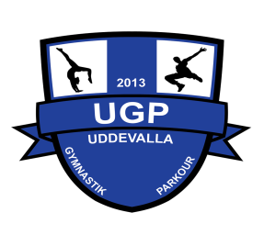**Coach and project manager WAG**

Uddevalla Gymnastics & Parkour Association

Uddevalla is a city with 60 000 inhabitants located on the Swedish west coast 1hr drive from Gothenburg and 2,5hr drive south from Oslo, the Norwegian capital.

Uddevalla Gymnastics & Parkour is an association that was founded in 2013 but has a long history as part of a bigger sports association (GF Kroppskultur) from 1920.

The association have ~600 active members and has a strong growth in all our branches that includes wag, parkour, cheerleading and basic child gymnastics.

The financial situation in the association is good and in balance, we are today 2,5 full time employees and has a total of ~50 coaches that are paid on an hourly basis. We are putting a high value on quality; safety and all our coaches are put in educational training on a regular basis that suites the specific needs within the association.

We are now searching for a Coach that will help us to take the next step in the development of both “elite” gymnasts and our association. As part of the mission, you will also lead the project in making WAG part of the elite sports high school in the city of Uddevalla where it later might be a potential opening as coach.

The daily work is to coach and train our WA gymnasts and together with our head coach set up short- and long-term plan for both individuals and the team. We think that you have a background as a gymnast on a higher national level and if you have international competition experience, we see that as a merit. A must is higher educational coaching background comparable with Swedish C or D-level and a couple of years’ experience as coach or head coach. English is a must and that you will take Swedish language training with the ambition to speak Swedish within a year.

Most of your work will be on evenings and weekends, you are traveling together with our gymnasts to national and eventual international competitions. You will also plan and lead training camps and be part of the local organisation arranging competitions.

To succeed in the role, we believe that you have:

* Experience as a coach for “Elite” WA Gymnasts
* Experience as a” Elite” gymnast on a national level. (International experience is a merit)
* Good Corporation skills and you are a structured person.
* Good pedagogical ability
* Have a positive and empathic attitude.
* Documented educational background within coaching on higher level (Equal to Swedish D or C-level)
* Experience from running sports/gymnastics related projects is seen as a merit.

The position is full time but can be lower if combined with education or other but never less than 50% of full time. We use a 6-month probation period or a fixed employment period. Salary to be negotiated.

Send your full application including CV and cover letter in Swedish or English to: anmalan@uddevallagp.se

If any question regarding the position, send an email to: anmalan@uddevallagp.se

We are looking forward to your application!